Euclidean Optimization

Definition
# Source: AI Source: Provided by: [Data Path: Persons Table -> ID Column: 1, Name_En Column: Motasem Essam] -> From: [ChatGPT] on [7/25/2026]
Euclidean Optimization is the study of finding the best possible solution to a problem involving points, distances, angles, lengths, areas, or other geometric quantities in Euclidean space.
The objective is to maximize or minimize a specified quantity while satisfying the geometric constraints of the problem.
Euclidean Optimization = Finding the geometrically optimal configuration under Euclidean constraints.
Typical objectives include:
- Finding the shortest distance between points or geometric objects.
- Finding the point on a line or curve closest to a given point.
- Maximizing the area of a figure under a perimeter constraint.
- Minimizing the total length of a geometric path.
- Finding the optimal location for a point, line, or other geometric object.
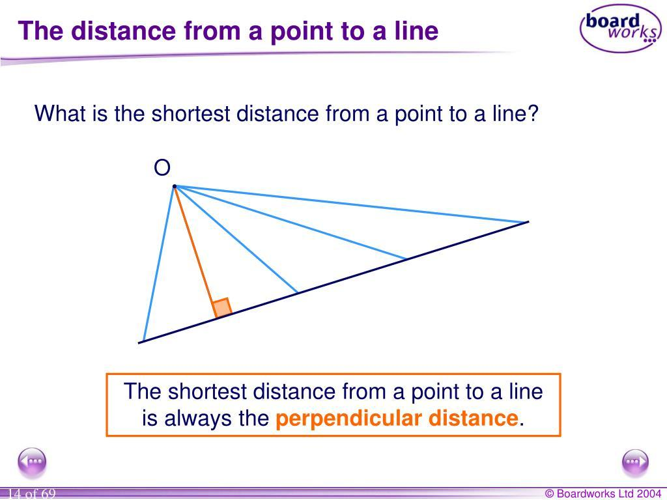
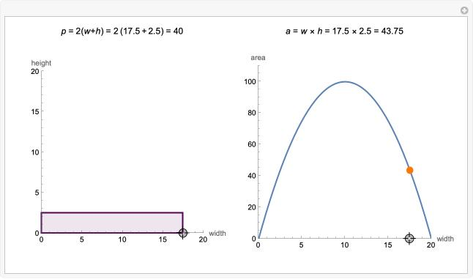
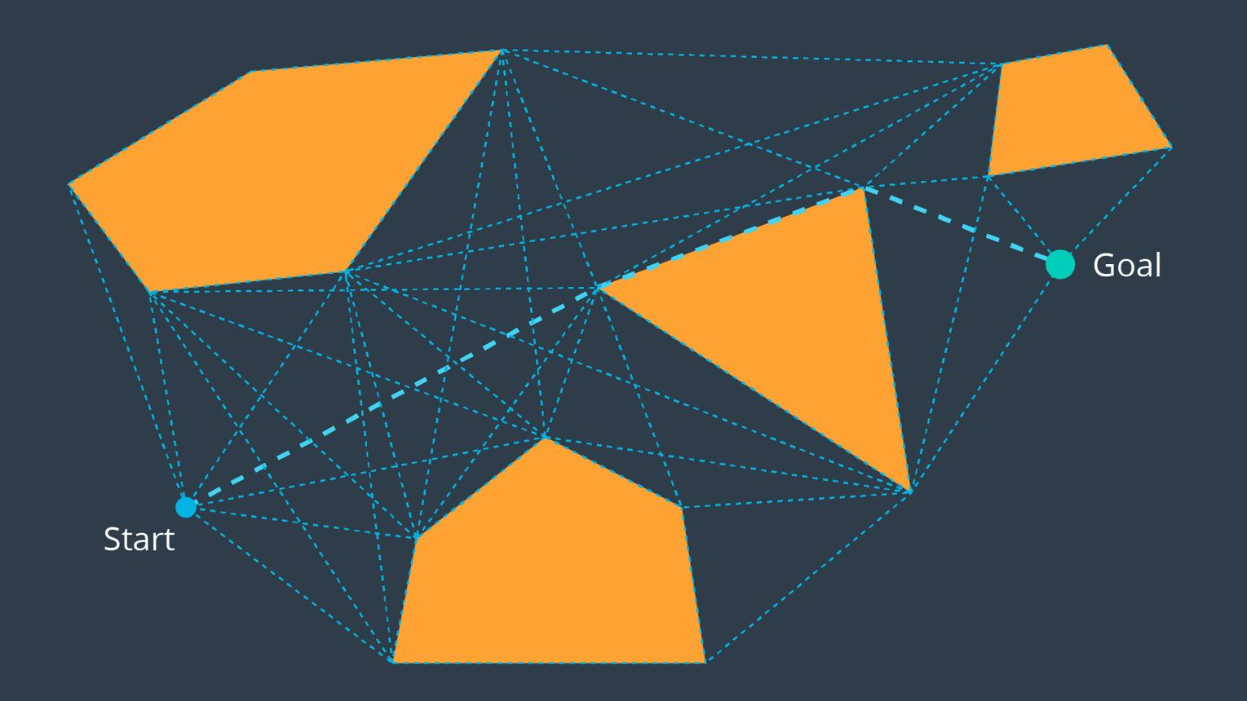
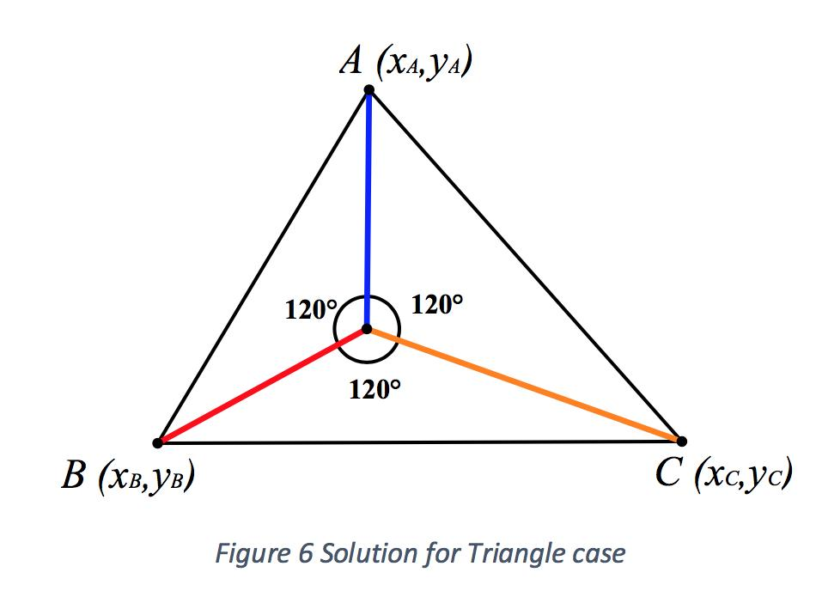

Fundamental Concept
# Source: AI Source: Provided by: [Data Path: Persons Table -> ID Column: 1, Name_En Column: Motasem Essam] -> From: [ChatGPT] on [7/25/2026]
An optimization problem has three main components:
- Decision variables: The geometric quantities that can change.
- Objective function: The quantity to minimize or maximize.
- Constraints: The geometric conditions that every admissible solution must satisfy.
The general mathematical form is
$$\boxed{\begin{aligned}&\text{Minimize or maximize }f\left(X\right) \\ &\text{subject to }X∈S\end{aligned}}$$
where $X$ represents a candidate geometric configuration, $f\left(X\right)$ measures its objective value, and $S$ is the set of feasible configurations.

Basic Structure
# Source: AI Source: Provided by: [Data Path: Persons Table -> ID Column: 1, Name_En Column: Motasem Essam] -> From: [ChatGPT] on [7/25/2026]
Mathematics
└── Optimization
└── Geometric Optimization
├── Distance Optimization
├── Length Optimization
├── Area Optimization
├── Volume Optimization
├── Path Optimization
└── Geometric Location Optimization
Classification note: Euclidean optimization is a broad term for optimization in Euclidean spaces. Geometric optimization is a closely related field concerned with optimizing geometric configurations; computational geometry studies algorithmic solutions to many such problems.

Main Types of Euclidean Geometric Optimization
# Source: AI Source: Provided by: [Data Path: Persons Table -> ID Column: 1, Name_En Column: Motasem Essam] -> From: [ChatGPT] on [7/25/2026]

1. Distance Optimization
# Source: AI Source: Provided by: [Data Path: Persons Table -> ID Column: 1, Name_En Column: Motasem Essam] -> From: [ChatGPT] on [7/25/2026]
Minimizing or maximizing the distance between points or geometric objects.
Example: Finding the nearest point on a line to a given point.
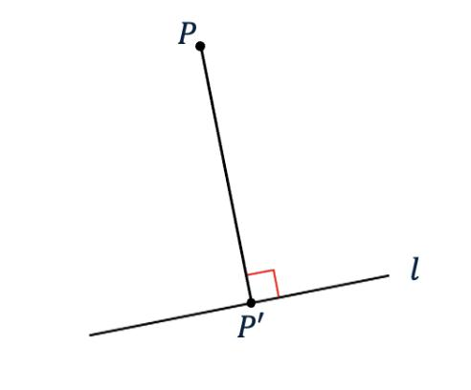

2. Area Optimization
# Source: AI Source: Provided by: [Data Path: Persons Table -> ID Column: 1, Name_En Column: Motasem Essam] -> From: [ChatGPT] on [7/25/2026]
Finding a geometric figure with the greatest or smallest area under specified constraints.
Example: Finding the rectangle with maximum area for a fixed perimeter.
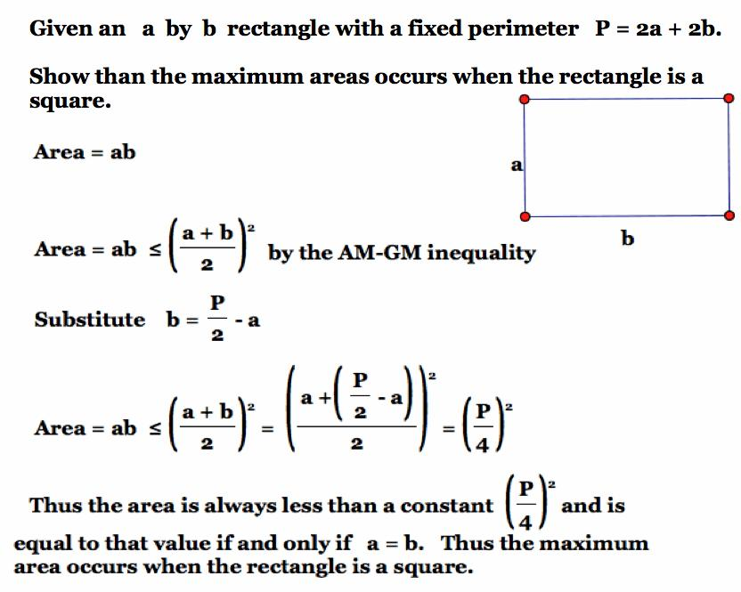

3. Point-Location Optimization
# Source: AI Source: Provided by: [Data Path: Persons Table -> ID Column: 1, Name_En Column: Motasem Essam] -> From: [ChatGPT] on [7/25/2026]
Finding an optimal location for a point according to a distance or other geometric criterion.
Example: Finding a point that minimizes the sum of distances to three vertices of a triangle.
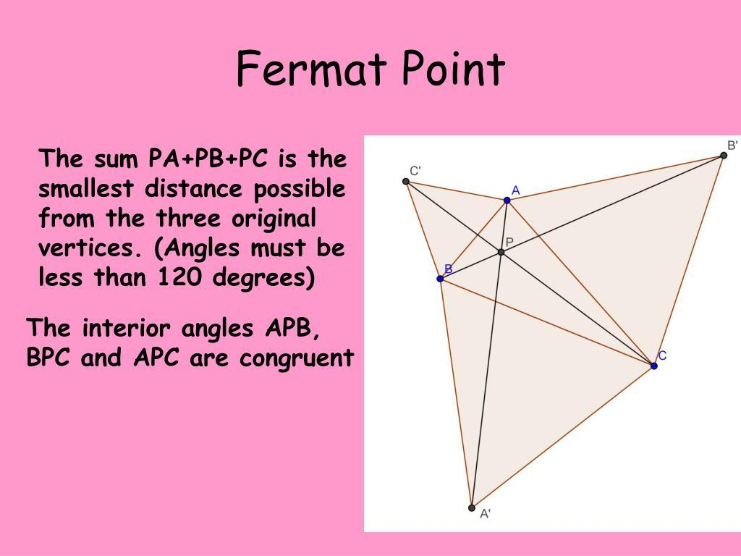

4. Path Optimization
# Source: AI Source: Provided by: [Data Path: Persons Table -> ID Column: 1, Name_En Column: Motasem Essam] -> From: [ChatGPT] on [7/25/2026]
Finding a path that minimizes length or another specified cost.
Example: Finding the shortest route between two points while avoiding polygonal obstacles.
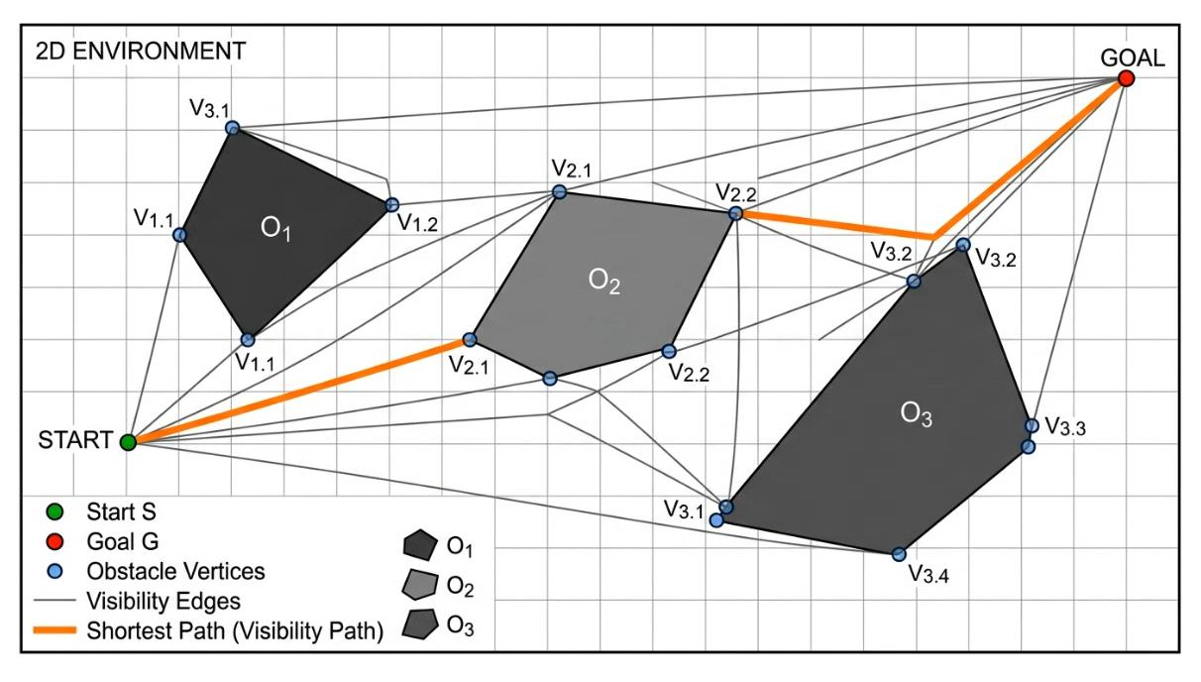

5. Enclosure Optimization
# Source: AI Source: Provided by: [Data Path: Persons Table -> ID Column: 1, Name_En Column: Motasem Essam] -> From: [ChatGPT] on [7/25/2026]
Finding the smallest or largest geometric object satisfying containment conditions.
Example: Finding the smallest circle enclosing a given set of points.
These categories are useful ways to organize common problems, rather than a single universally standardized classification.
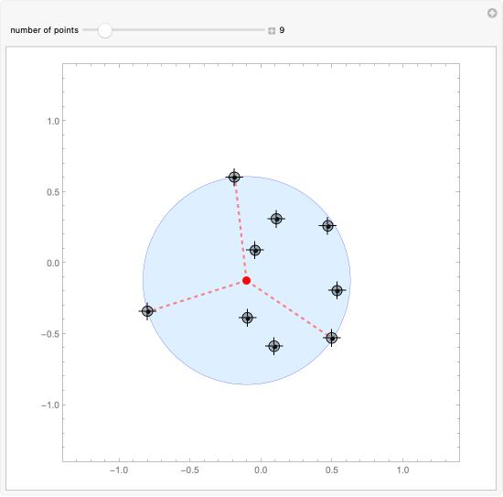

Mathematical Representation

1. Distance Minimization
# Source: AI Source: Provided by: [Data Path: Persons Table -> ID Column: 1, Name_En Column: Motasem Essam] -> From: [ChatGPT] on [7/25/2026]
For a fixed point $P=\left(a,b\right)$ and a variable point $X=\left(x,y\right)$, the Euclidean distance is
$$d\left(P,X\right)=\sqrt{{\left(x-a\right)}^{2}+{\left(y-b\right)}^{2}}$$
The optimization problem is
$$\boxed{\min_{X∈S}{d\left(P,X\right)}}$$
where $S$ is the permitted geometric set, such as a line, curve, or region.

2. Area Maximization
# Source: AI Source: Provided by: [Data Path: Persons Table -> ID Column: 1, Name_En Column: Motasem Essam] -> From: [ChatGPT] on [7/25/2026]
For a rectangle with length $x$ and width $y$, subject to a fixed perimeter $p$,
$$2x+2y=p$$
Its area is
$$A=xy$$
The optimization problem is
$$\boxed{\max{x}y \text{subject to }2x+2y=p}$$
The maximum occurs when the rectangle is a square:
$$\boxed{x=y=\frac{p}{4}}$$

3. Shortest-Path Optimization
# Source: AI Source: Provided by: [Data Path: Persons Table -> ID Column: 1, Name_En Column: Motasem Essam] -> From: [ChatGPT] on [7/25/2026]
For a path $γ$ connecting points $A$ and $B$, the objective is to minimize its length:
$$\boxed{\min_{γ:A→B}{L\left(γ\right)}}$$
If no obstacles or other restrictions are present, the straight line segment $AB$ is the shortest path in Euclidean space.

Euclidean Optimization vs. Euclidean Geometry
# Source: AI Source: Provided by: [Data Path: Persons Table -> ID Column: 1, Name_En Column: Motasem Essam] -> From: [ChatGPT] on [7/25/2026]
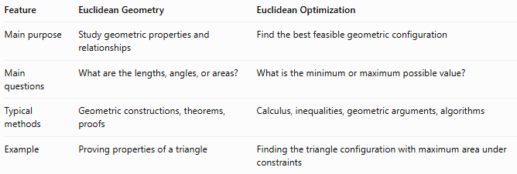
Feature | Euclidean Geometry | Euclidean Optimization
Main purpose | Study geometric properties and relationships | Find the best feasible geometric configuration
Main questions | What are the lengths, angles, or areas? | What is the minimum or maximum possible value?
Typical methods | Geometric constructions, theorems, proofs | Calculus, inequalities, geometric arguments, algorithms
Example | Proving properties of a triangle | Finding the triangle configuration with maximum area under constraints

Applications
# Source: AI Source: Provided by: [Data Path: Persons Table -> ID Column: 1, Name_En Column: Motasem Essam] -> From: [ChatGPT] on [7/25/2026]
- Architecture and Engineering: Optimizing dimensions, layouts, and material use.
- Transportation: Finding shortest routes.
- Computational Geometry: Solving geometric problems involving distances, enclosures, and paths.
- Facility Location: Choosing locations that minimize travel distances.
- Industrial Design: Optimizing shapes and dimensions subject to constraints.

Key Points
# Source: AI Source: Provided by: [Data Path: Persons Table -> ID Column: 1, Name_En Column: Motasem Essam] -> From: [ChatGPT] on [7/25/2026]
- Euclidean optimization seeks optimal solutions in Euclidean space.
- The objective may involve distance, length, area, volume, or another measurable quantity.
- Constraints define which geometric configurations are permitted.
- Solutions may be found using geometric theorems, inequalities, calculus, or computational algorithms.
- Geometric optimization is a closely related field, while computational geometry emphasizes algorithmic methods.

Conclusion
# Source: AI Source: Provided by: [Data Path: Persons Table -> ID Column: 1, Name_En Column: Motasem Essam] -> From: [ChatGPT] on [7/25/2026]
Euclidean Optimization concerns finding the minimum or maximum value of a geometric objective within a set of permitted configurations in Euclidean space. Its problems include distance minimization, area maximization, shortest paths, optimal point locations, and geometric enclosure. It connects classical Euclidean geometry with optimization theory and computational geometry.

